Important Note
For updating the credentials for an existing site, jump to Register Add-In using the AppRegNew form

For creating a new site, this Manual is Deprecated - New Manual Here
This manual is relying on Basic Authentication, which is deprecated by Microsoft.
Use this manual only to renew credentials for existing SharePoint sites, not for creating new ones.

Create a New Site

Step 1 - Start Creation - Method #1
- Go your organization’s SharePoint (https://<myorgname>.sharepoint.com/)
  - Login with customers tenant aip-service user
- Looking for the ‘Create site’ button on the top-right of the SharePoint site.

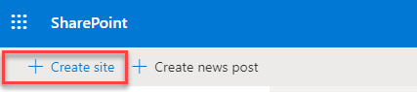

Step 1 - Start Creation - Method #2 (only in case Method #1 was not applicable)
If the ‘Create site’ and ‘Create news post’ button don’t appear, try the following:
- Go to https://admin.microsoft.com/AdminPortal/
  - Login with customers tenant aip-service user
- Click ‘Show all’
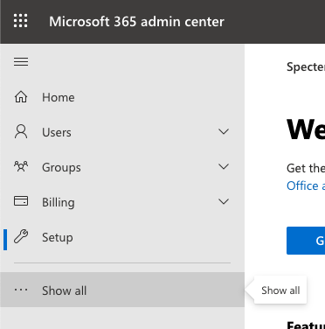
- From the new list that opened, click ‘SharePoint’
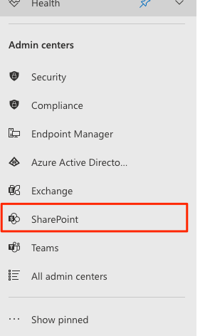
- On the left-side menu, click ‘Sites’ and then ‘Active sites’
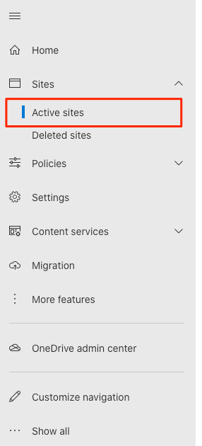
- On the new page the loaded, below the big ‘Active sites’ title, find and click the ‘Create’ option
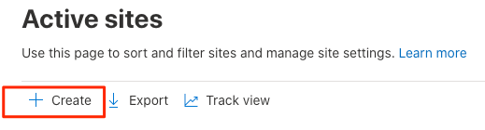

Step 2 - Configure Created Site
- Select “Team site”
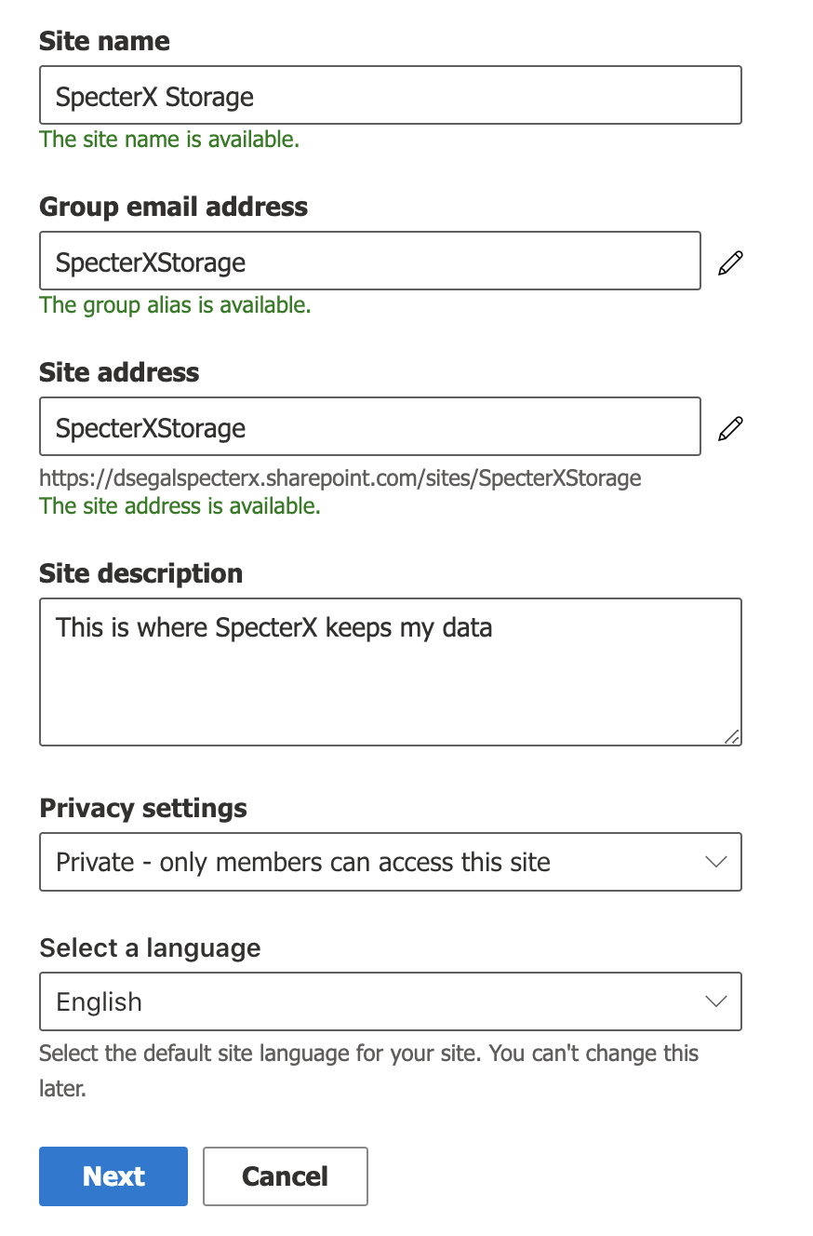
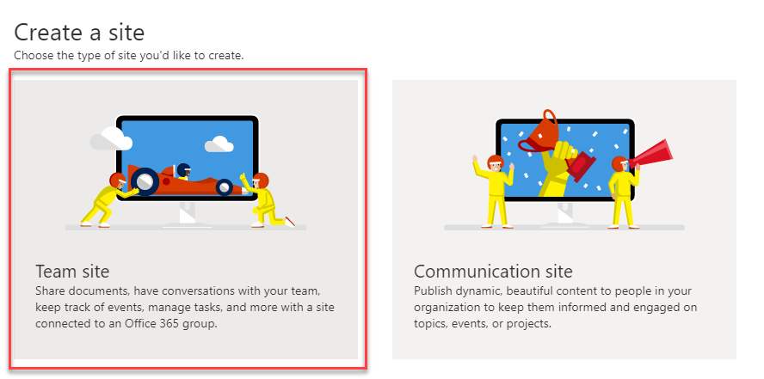
- Setup the site using those parameters:
  - Site name: “SpecterX Storage”
  - Site description:
“This where Specter keeps my data”
  - Language: English
  - Privacy settings: “Private”
  - Group owner (if requested): Your email address

- Click “Next”
- If a “Who do you want to add?” step is shown, just click “Finish”. You can change this setting later.
- Congratulations, the site is now successfully created!
- Copy the url from the browser’s address bar and save it as ‘Site URL’.
It should be something like: yorgname.sharepoint.com/sites/SpecterXStorage
You will use this Site URL in the next steps as a baseline for other pages you’ll visit.
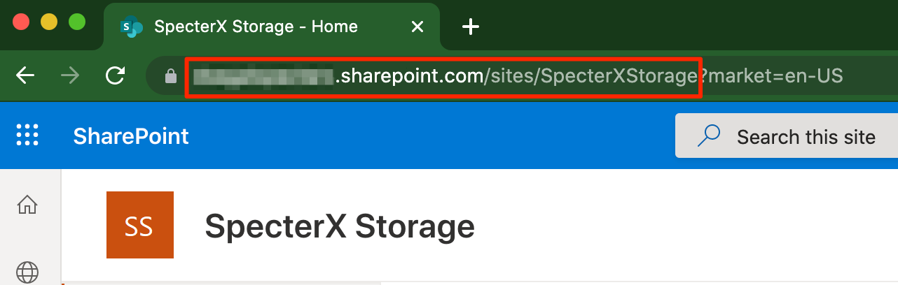

In the next segment we’ll give the SpecterX platform permissions to save files to this site.

SharePoint API Permissions

Enable App Permissions on your SharePoint
For a new SharePoint subscription ‘Grant App Permission’ is disabled by default.
This is a feaure that’s required on the next steps, so let’s make sure it’s turned on.

There are 2 options for allowing Grant App Permissions, the first option is via GUI and the second option is via PowerShell CLI.

Enabling App Permissions on your SharePoint via SharePoint GUI
- In your browser, navigate to - [Site URL]/_layouts/15/ManageFeatures.aspx
- In the opened web page find "Workflows can use app permissions"
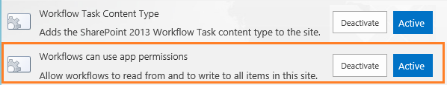
- Make sure it is Active. If not, activate it.

Enabling App Permissions on your SharePoint via PowerShell CLI
This is required only if you couldn’t find the ‘Activate’ button through the previous method.

To enable this feature, we need to connect to SharePoint using Windows PowerShell and run:
Install-Module -Name Microsoft.Online.SharePoint.PowerShell
$adminUPN="<the full email address of a SharePoint administrator account>"
$orgName="<name of your Office 365 organization>"
$userCredential = Get-Credential -UserName $adminUPN -Message "Type the password."
Connect-SPOService -Url https://$orgName-admin.sharepoint.com -Credential $userCredential
set-spotenant -DisableCustomAppAuthentication $false

Register Add-In using the AppRegNew form
Now that SharePoint is ready to give permissions, we’ll create an application within the site we’ve created that has permissions to read and write files to the site.
- Navigate to - [Site URL]/_layouts/15/AppRegNew.aspx
- Click on “Generate” for “Client Id” and “Client Secret”. Save the generated values together with the Site URL from before.
- Fill in the rest with the following params:
  - Title: SpecterX Secure Sharing
  - App Domain: www.specterx.com
  - Redirect URI: https://www.specterx.com
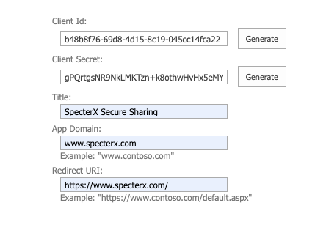
- If you didn’t copy the Client ID and Client Secret on the previous step, you can copy them now. Notice: Past this point you won’t be able to recover the Client Secret.
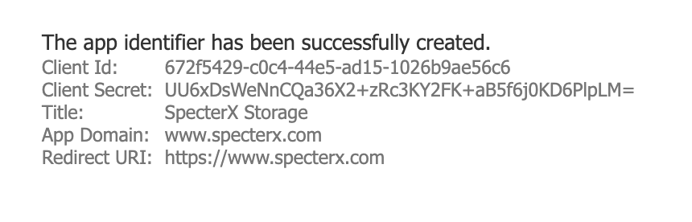

Grant permissions to the add-in
- Navigate to [Site URL]/_layouts/15/AppInv.aspx
- In the “App Id” field insert the client Id from the previous step and click on “Lookup”
- On the Permissions Request XML insert this and click “Create”

<AppPermissionRequests AllowAppOnlyPolicy="true">
<AppPermissionRequest
Scope="http://sharepoint/content/sitecollection/web"
Right="FullControl" />
</AppPermissionRequests>

This provides access to files on SharePoint sites
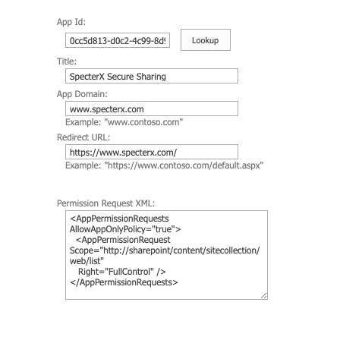
- On the next screen click on “Trust It”
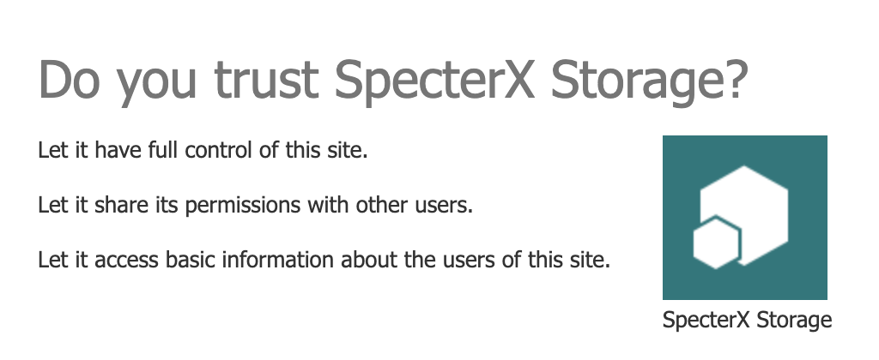

Disable Offline Sync
Not all default features are required when setting up a SharePoint site, let’s disable some.
- Navigate to [Site URL]/_layouts/15/srchvis.aspx
- Change the following settings:
  - “Allow this site to appear in search results?” - Set to “No”
  - “Allow items from this site to be downloaded to offline clients” - Set to “No”

Find the ‘Realm ID’ value
- Navigate to [Site URL]/_layouts/15/AppPrincipals.aspx
This is the Site Collection App Permissions page.
- Identify the row with your registered application and locate it at the App Identifier column. Site Realm ID corresponds to the part of App Identifier followed after the last @ delimiter.

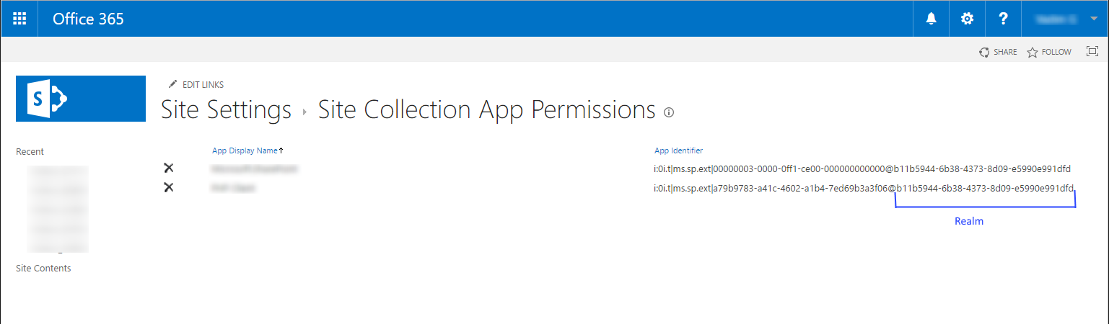

- Copy this part and save it as Realm ID together with the Client ID, Client Secret and Site URL.

Submit to SpecterX
- Finally, log in with and Admin user to SpecterX web application in https://{your-site}.specterx.com/settings
- Fill in ‘Site URL’, ‘Client Id’, ‘Client Secret’ and ‘Realm ID’ in the SharePoint section and click ‘Save’.
- That’s it! SpecterX is now configured to save you sensitive materials on your own organizational storage

